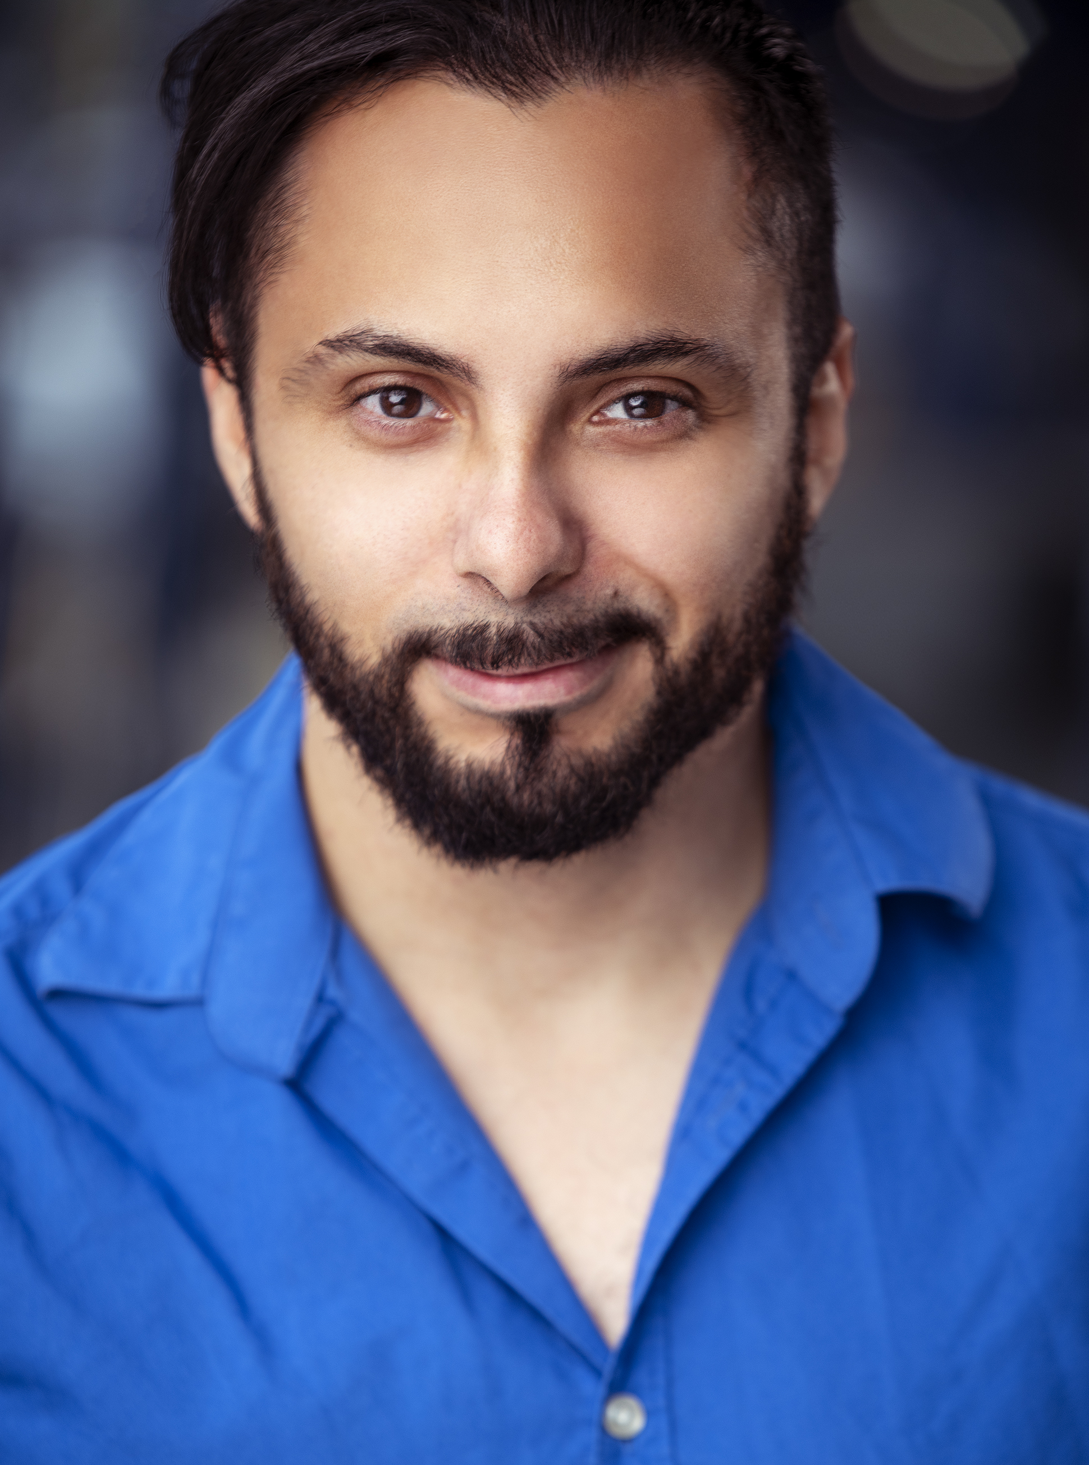
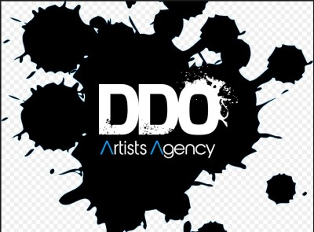
Angelo Mercado Jr.
SAG-AFTRA


URL: angelomercadojr.com
imdb.me/angelo
Film and Television
Little Voice Co-Star J.J. Abrams/AppleTV
Aghast! Lead Vincent Ruiz
Splat! Series-Regular Heidi Bordogna
Do Not Disturb Guest-Star Joel Schumacher
The Hunt /W John Walsh Guest-Star CNN
Young, Hot, and Deadly Co-Star Discovery ID
These Three Girls Co-Star Teresa Hui
Celebrity Ghost Stories Co-Star Discovery ID
On the case with Paula Zahn Guest-Star Discovery ID
The Colbert Report Voice-Over Comedy Central
Frog Kissers Recurring Debra Kirschner
Dead Man Working Supporting L.E. Salas
Finale Lead Michael Chan
WW4: Rise and Fall of the NWO Lead B.A Brooks
My Terms Lead Eric Garcia
Utopia lies at the horizon Lead Leo Curbelo

Commercials & Print
Conflicts upon Request

Theater
Gary and Susan Gary (Lead) Producers Club Theater
No Class Ensemble Producers Club Theater
Le Chateau Gentleman (supporting) Paul Robeson Theater
Stand-Up Comedy Self NY Comedy Club
UCB Improv Show Ensemble UCB East Theater

Actor Training
Ted Sluberski: On Camera Scene Study
Craig Archibald: On Camera Scene Study
Marci Phillips: On Camera Technique
Bob Krakower: On Camera Audition
Dena Tyler: Audition Technique
Darlene Violette: On Camera
Louise Lasser – Meisner
Upright Citizens Brigade: Improv 101 – John Timothy and Phil Jackson; Improv 201 Nicole Drespel
T.Schreiber Studios Page Clements – Vocal Production
T.Schreiber Studios Peter Miner On-Camera Technique
Roger Delpozo – On Camera Commercial
Diana Lote – Voice-Over
Andrew Hurley – Shakespeare
Brette Goldstein – On camera Acting for Film
Larkin Malloy – Scene Study
Clayton Fletcher – Stand-Up Comedy

Skills
Fluent in Spanish, Martial Arts (Tae Kwon Do and Kendo), Computer Skills, Typing, Cooking, Baking, Bicycling, Running, Bowling, Baseball, cock eyebrow, Burp on command, Wiggle ears, curl lip, finger snake.

